ORANGE POLICE DEPARTMENT
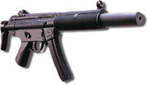
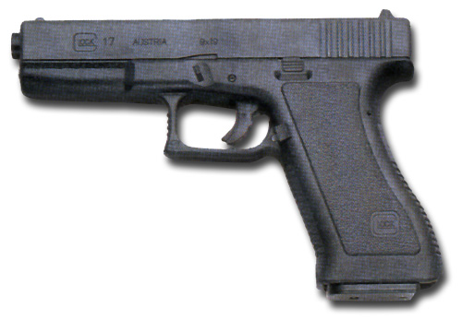

SAFETY ALERT

AIR SOFT WEAPONS

Recently, the Orange Police Department has responded to several calls involving juveniles playing with guns. Although these incidents involve mainly airsoft weapons, the Police Department CANNOT UNDERESTIMATE THE POTENTIAL FOR LETHAL INJURY in these situations. The guns shown on this page are examples of actual air soft weapons. As you can see, they appear very realistic. THEY ARE INDISTINGUISHABLE FROM ACTUAL FIREARMS even to law enforcement. Life or death circumstances require split-second decision-making. Each call is taken very seriously and acted upon, until determined otherwise, as though the weapons are real firearms.

If contacted by police, immediately place the weapons on the ground and follow all instructions given by police. Do not make any sudden movement. Follow Directions.

Airsoft weapons are replica air-powered firearms that shoot 6mm plastic pellets. Since the guns fire pellets of plastic BBs at low velocity, many youth use them to play combat games and shoot each other. They are nearly identical to the actual firearms and often contain interchangeable parts. As such, THEY ARE INDISTINGUISHABLE FROM ACTUAL FIREARMS AND SHOULD NOT BE DISPLAYED IN PUBLIC PLACES. Many owners remove the required safety marking to make the weapon appear more realistic. Although marketed as such, they are not toys and can result in serious injury. All related safety material urges caution in use, including the wearing of protective gear, and supervision. The material also advises users, “YOU SHOULD NEVER DISPLAY YOUR AIRSOFT WEAPON IN PUBLIC OR HAVE IT SITTING IN THE OPEN IN A VEHICLE.”

Crimes committed with airsoft guns carry the same penalty as those committed with actual firearms, including brandishing a firearm to threaten someone, or brandishing in a threatening manner.

The Orange Police Department offers this information in an effort to prevent accidental injury to anyone. We strongly urge parents to consider and discuss all of the safety implications and dangers before allowing their children to play with these weapons. If a decision is made to allow use of air soft weapons, it should be done in secure private environment with responsible adult supervision, and proper safety equipment.

